Project Report Title

# 1.Introduction

### 1.1.Overview :

A brief description about your project

### 1.2. Purpose :

The use of this project .What can be achieved using this

# 2.Problem Statement & Design Thinking

### 2.1.Empathy map :

Paste the empathy map screenshot

### 2.2.Ideation and Brainstorming Map :

Paste the Ideation & brainstorming map screenshot

# 3.Result

Final finding (output) of the project along with screenshots

# 4.Advantages & Disadvantages

List of advantages and disadvantages of the proposed solution

# 5.Applications

The areas where this solution can be applied

# 6.Conclusion

Conclusion summarizing the entire work and findings

# 7.Future Scope

Enhancements that can be made in the future

THE WHOLESALER CUSTOMER ANALYSIS

# 1.Introducation

#### 1.1.Overview:

A wholesale distributor operating in different regions of Portugal has information on annual spending of several items in their stores across different regions and channels . Based on different items on which the consumer spend annually we’ll evaluate the total spending on various items through which channels and in which region .In this problem statement we will explore the spending on different items by customer

1.2. Purpose :

The purpose is to explore the dataset and do the exploratory data analysis . The data consists of 440 large retailers’ annual spending on 6 different varieties of products in 3 different region (Lisbon, Oporto, Other) and across different sales channels. The idea is to draw various conclusions using measures of central tendency ,contingency tables , conditional probabilities and hypothesis testing

## 2.Problem Definition & Design Thinking

2.1 Empathy Map

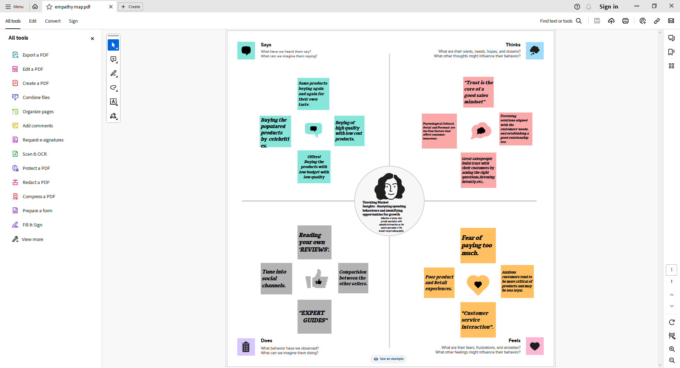

2.2Ideation & Brainstorming Map

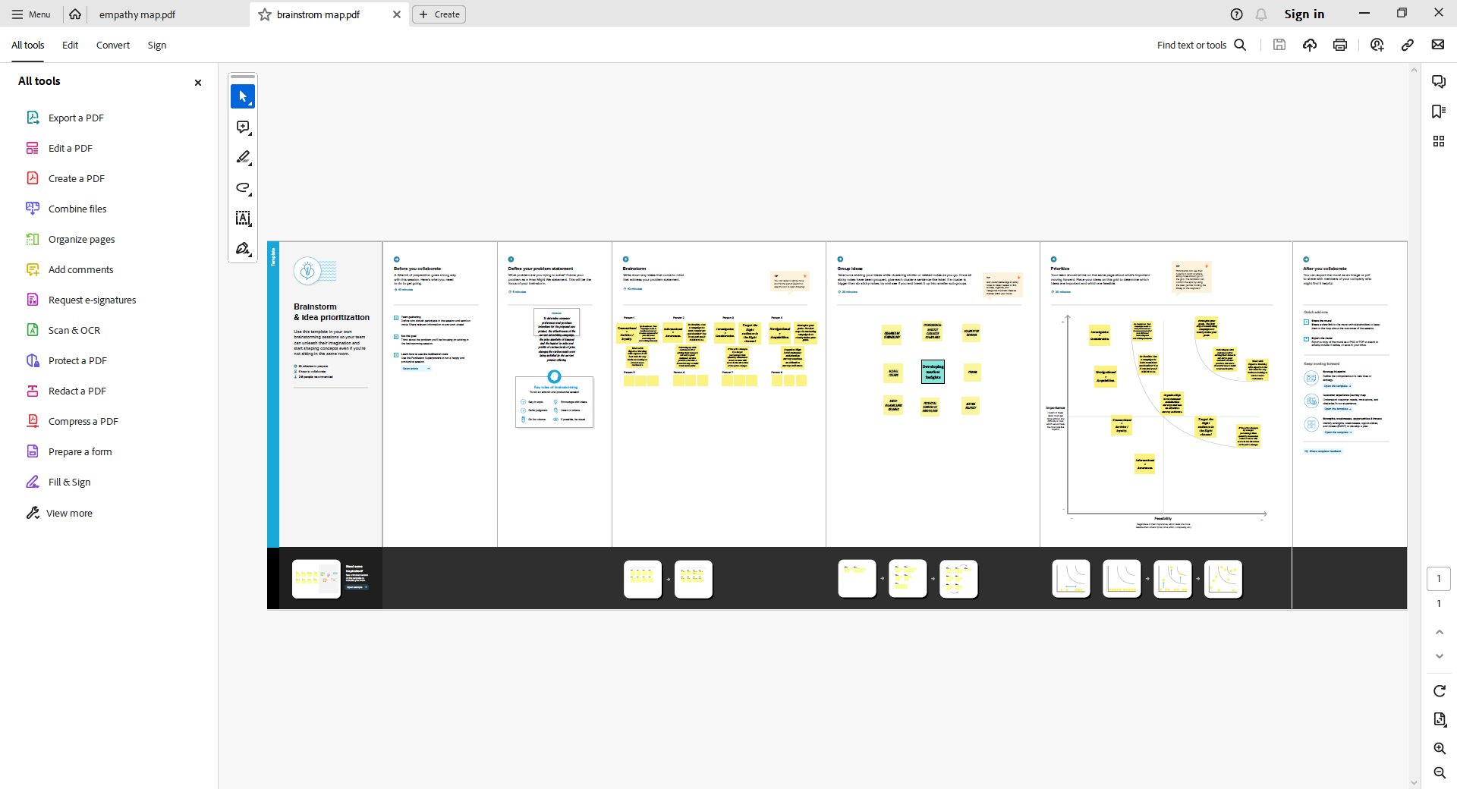

# 3.Results

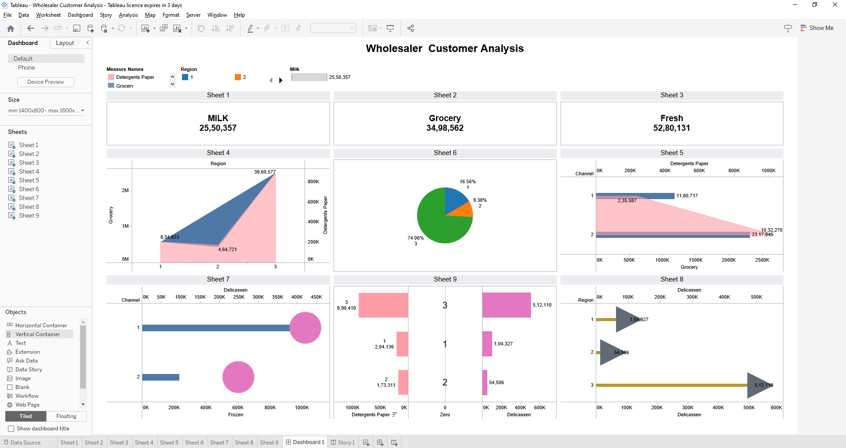

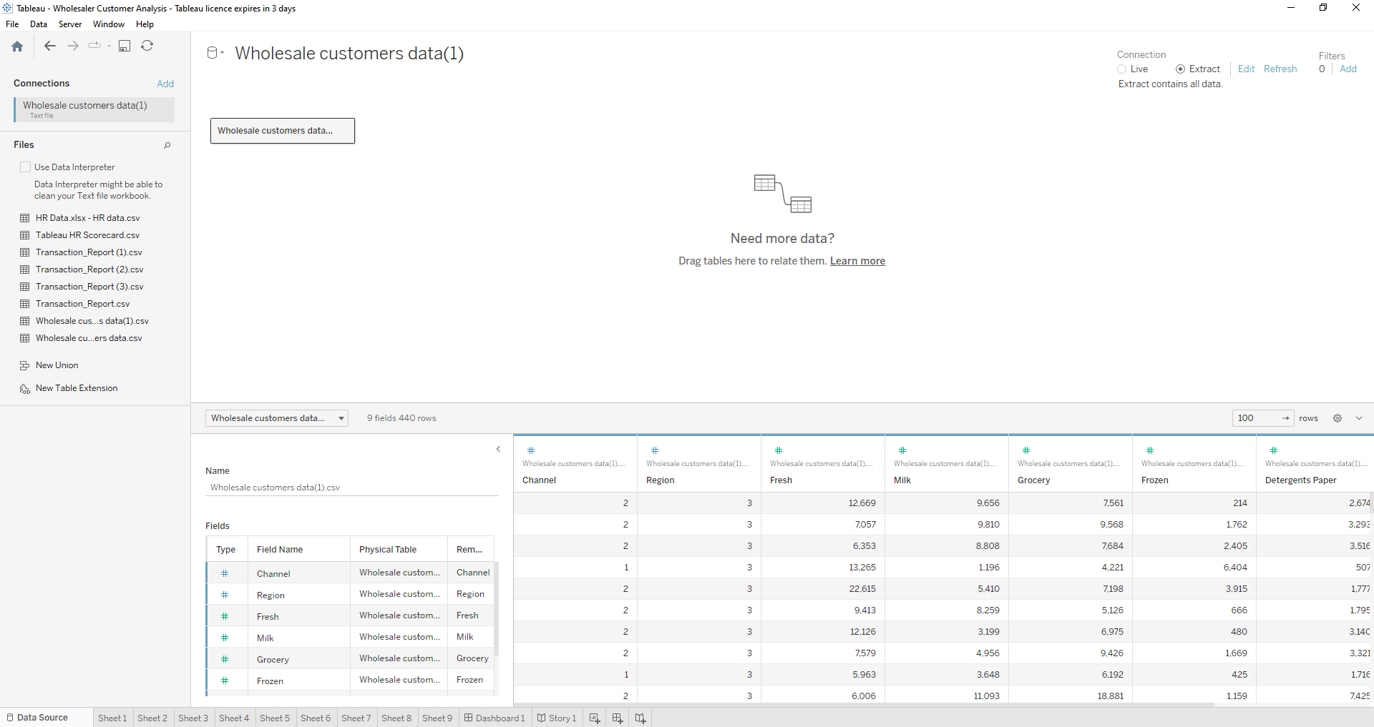

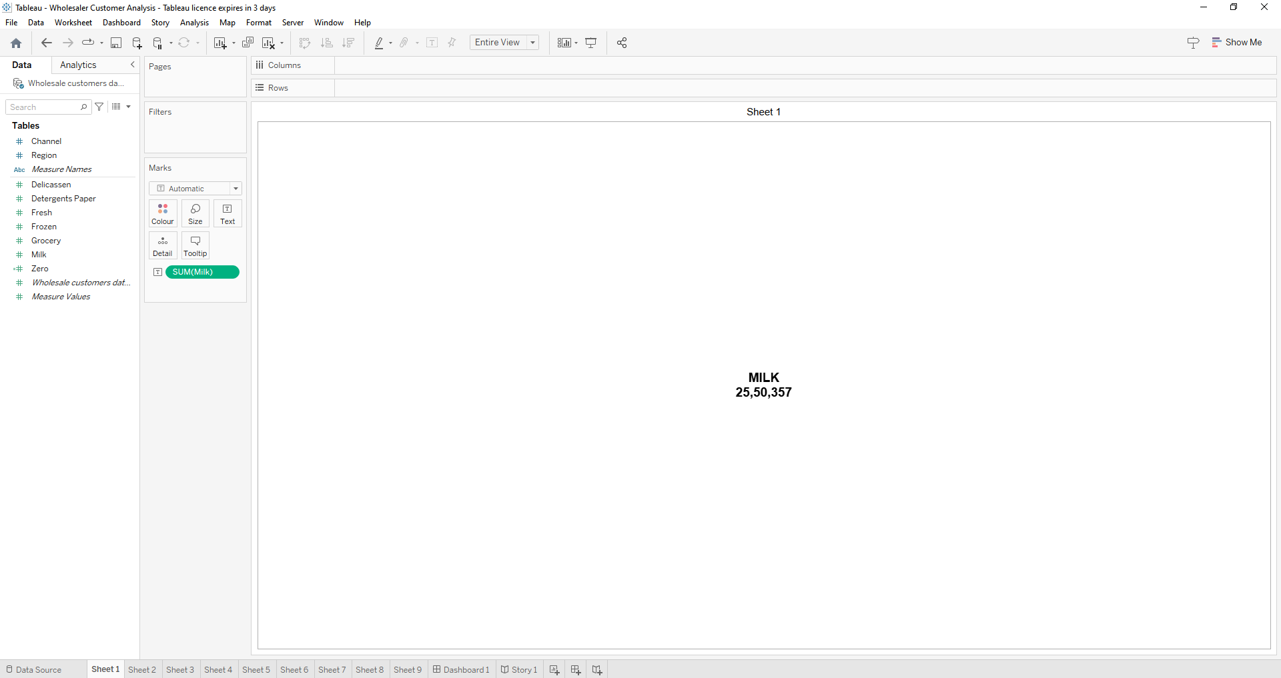

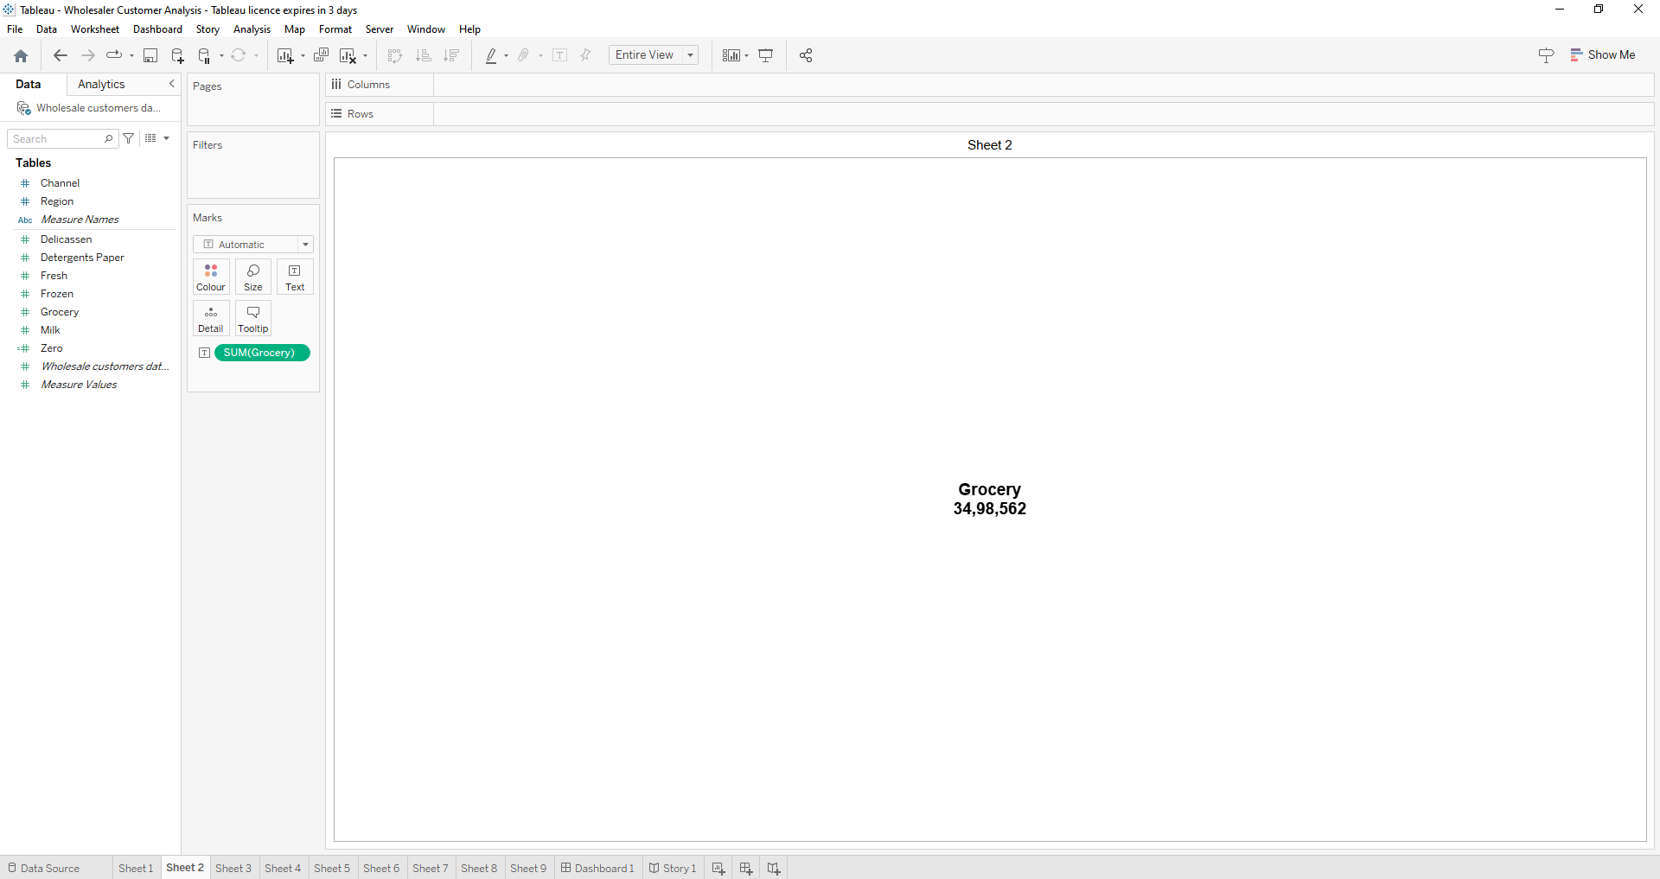

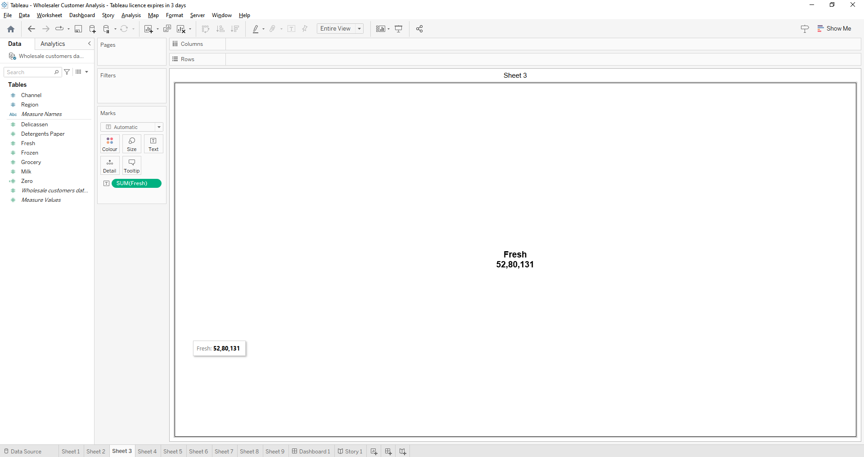

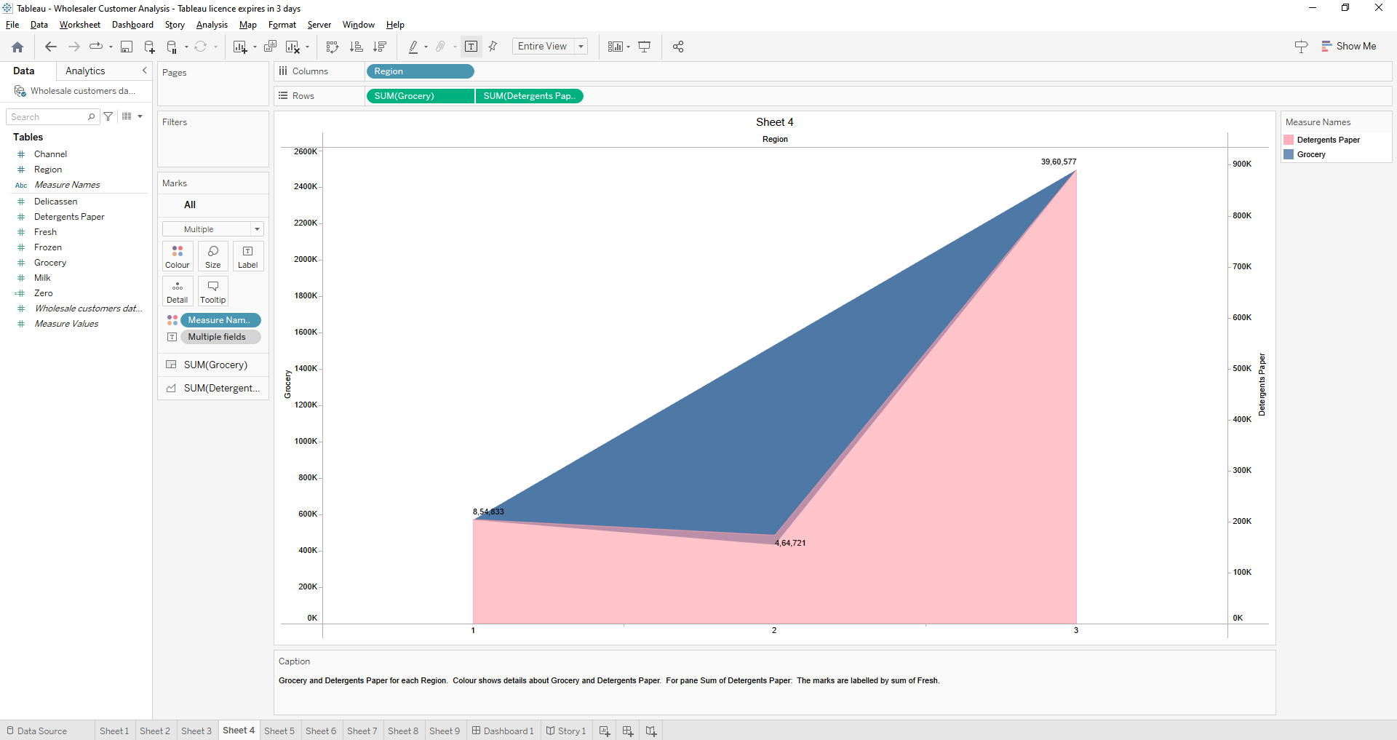

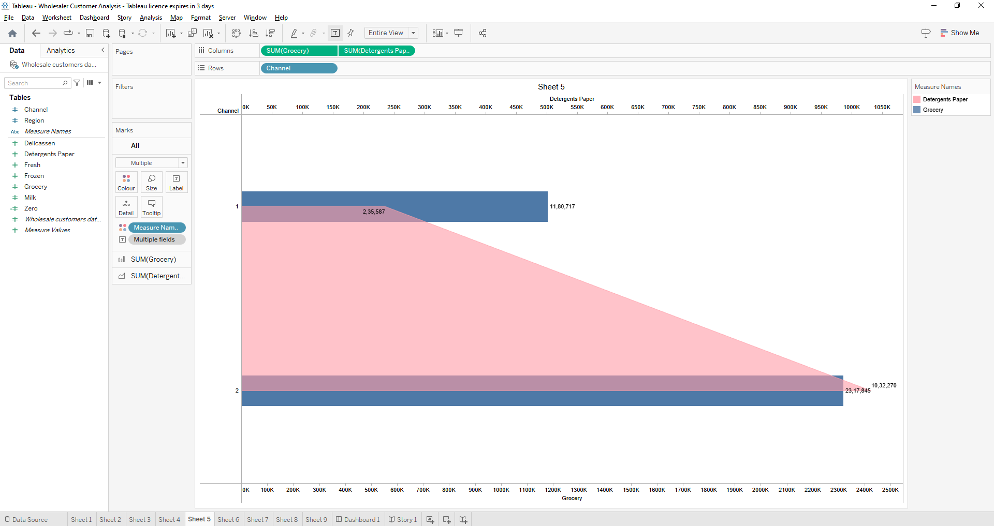

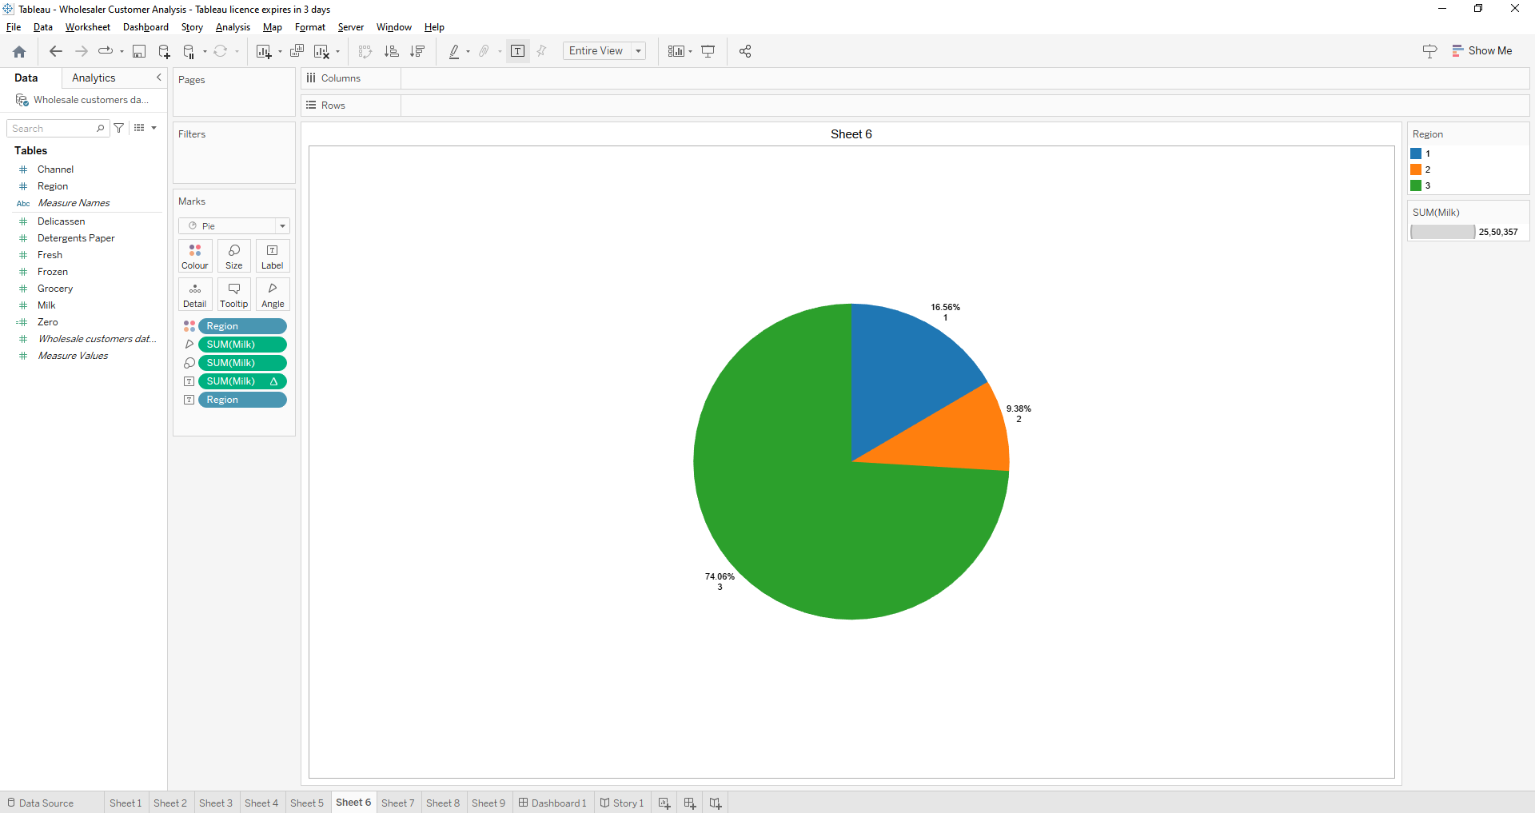

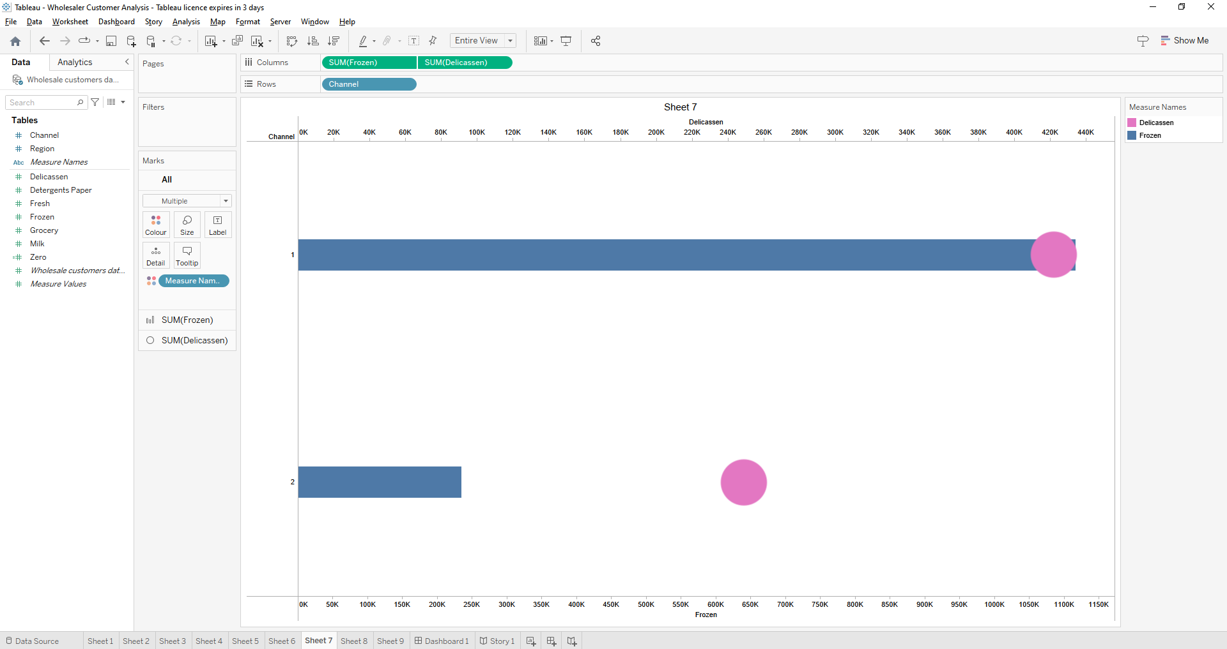

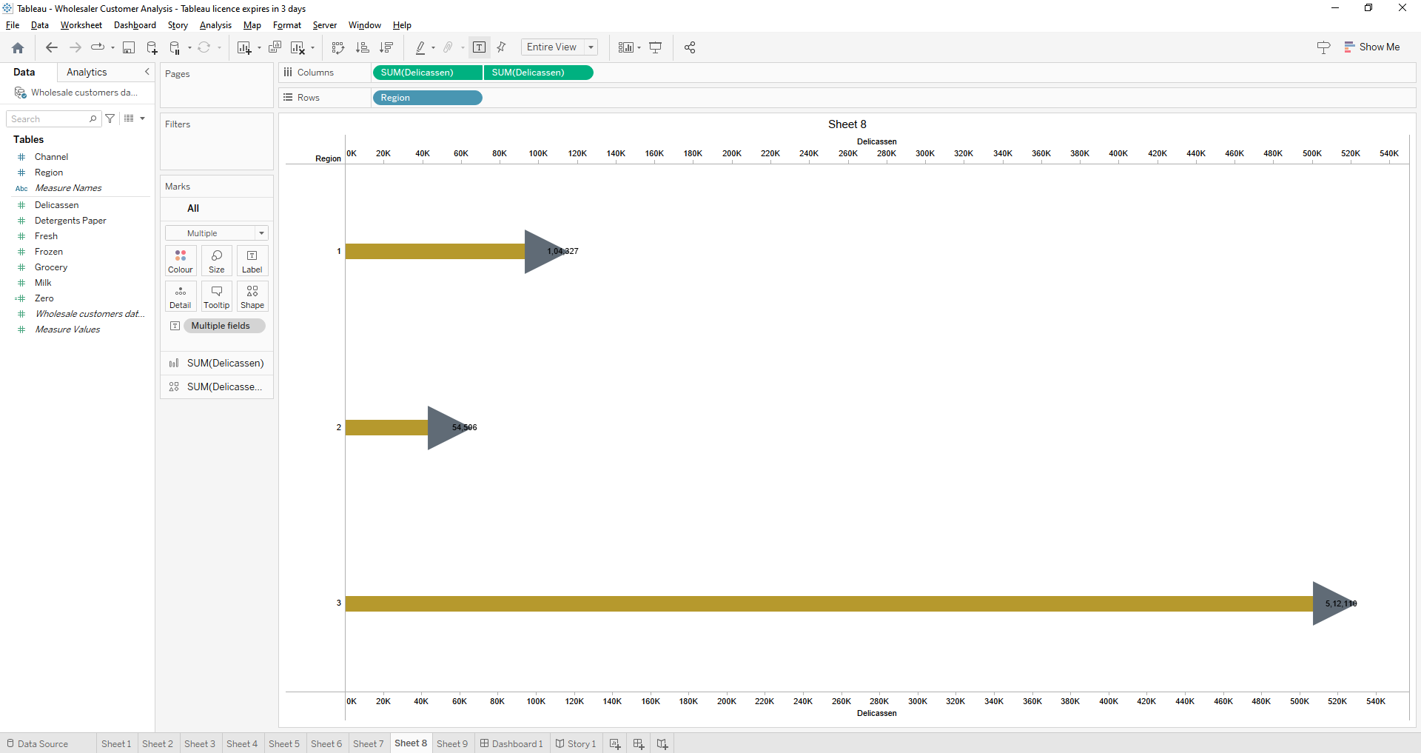

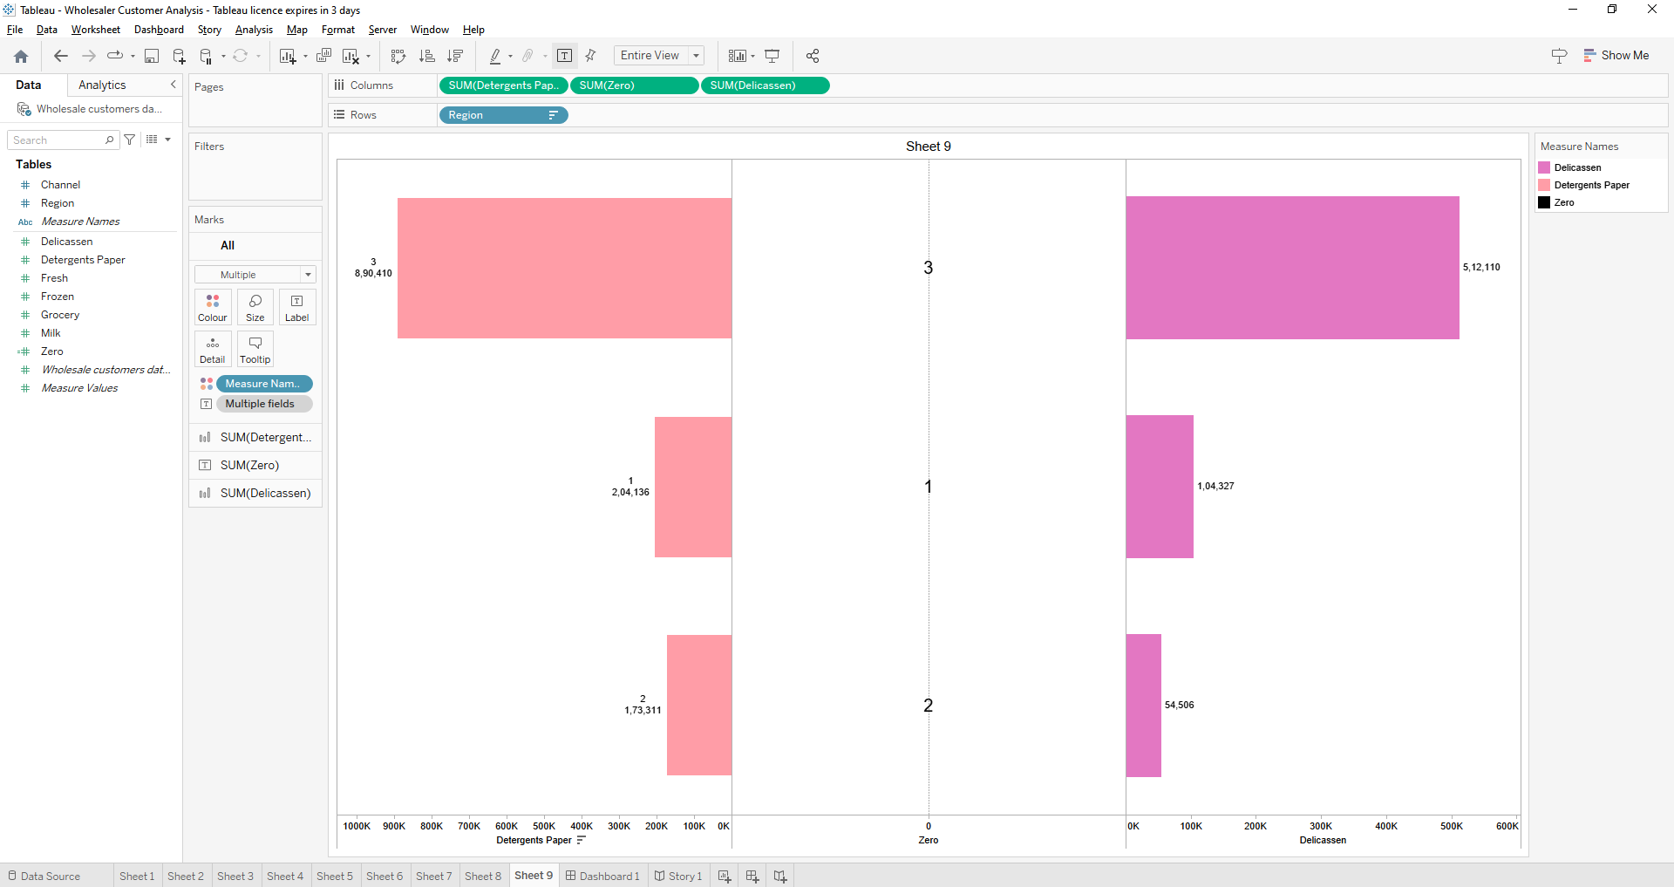

# 4.Advantages & Disadvantages

### Advantages :

1.Gives structure to the strategy

2. Improves performances reporting

3.Makes it easier to communicate the strategy

4. Connects every wholesaler customer

## Disadvantages

1.Wholesalers are not usually a direct sales channels to consumers

2. They cannot have complete controls over how retailers get products to customers

3.Whether consumers have a positive or negative view of your products depends largely on the retailer.

# 5.Applications

These are the most popular used in the private label, FMGG, and agricultural industries…Full service merchant wholesaler and limited service merchant wholesaler

# 6.Conclusion

The wholesale industry is a key components of the supply chain, providing a crucial link between manufacturing and retailers . By buying and selling goods in bulk , wholesaler help to ensure that products are available to retailers and ultimately ,to end customers .

# 7.Future scops

The wholesaler of the future is not merely a one-stop shop but an end-to-end value added service provider ,a direct –to-customer agent .Wholesalers main aim is to sell good to businesses or retailers and they sell it futher.

*THE END *

*************************************************************************************